Before You Start

Depending on the settings in your state, when a member reaches 18 (or the age set in the state options), at the next re-enrollment, the member is given the option to enroll as a youth or as an adult. Sometimes they become confused about the difference, and mistakenly enroll as an adult. Their record can be returned to the Youth role using the Data tab.
- This function is available at both the state manager and county manager level.
- The record must not be Active when doing this process—return it to Pending, Incomplete or Inactive if necessary before beginning.

Steps  - Click on the Data tab, then the Member Options icon on the dashboard.  - Begin entering the first letters of the person’s name (either first or last name).  - When the popup list of possible matching names shows up, click on the correct one.  - Click the orange Select Member button.  - Click on the top option “Change Role Rollback”. | Screenshots  (Screen appearance may vary per state)  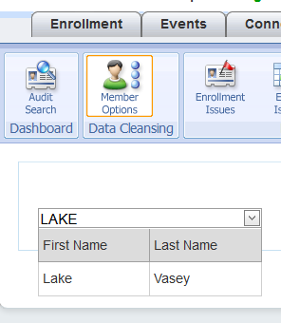  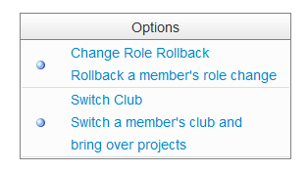
Tips

If it works as it should, there won’t be any further action needed.

Double check by going back to the search screen or the family list screen.

The record will be Inactive, just as it was before the member began the re-enrollment process. Any data entered onto the “Adult” record is gone, and will need updated on the newly correct “Youth” record.

