Overview
Health and emergency contact information can be printed in one of two ways – either for one member (youth or adult) or for a group of members.

For one member
After logging in:
- Navigate to the [Member List] screen.
- In the Member Reports section, select a [Member]
- Click on [Member – Health Form]
- A PDF report will pop up, or display in your browser. If the PDF does not pop up, check any popup blocker settings and/or try a different web browser.

Note - When the family logs in, they will see these same [Member Reports] options and and can print the same report.

For multiple members
As a Manager, you can print health forms for a batch of members, based on filter criteria of your choosing, as follows:
- Click on the [Reports] icon
- Click on the [Standard Reports]
- At the top are two quick filters that can be applied (4-H Year and Club)

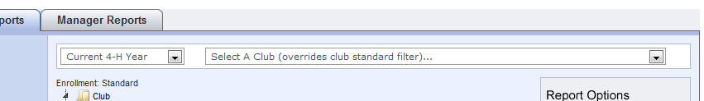

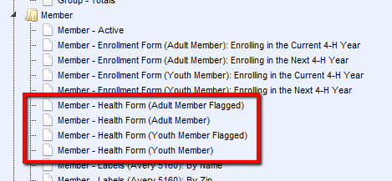
- Looking under the [Member] folder there will be four [Health Form….] options
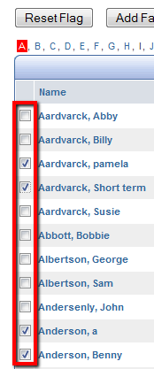

- The two options without [Flagged] will generate one long PDF with all [Adult] or [Youth] members, with above mentioned filter(s) applied, if chosen.
- The [Flagged] options will generate one long PDF with only those [Adults] or [Youth] who have been flagged on the main [Search] screen.
Generating multiple health forms represents a major load on the server, so it may take longer than expected before they appear on the screen.

While it is possible to [Memorize] a [Health Form…] report, there is no point in doing so, as a memorized [Health Form] report will not offer any usable options.

