Enrolling in 4H Online as a NEW Family

Your county Extension office staff can help you find a club, get the forms you need, and begin the enrollment process, whether you do that with a paper form, or online in 4H Online.
- New Castle County Extension Office - 302-831-8965
- Kent County Extension Office - 302-730-4000
- Sussex County Extension Office - 302-856-7303

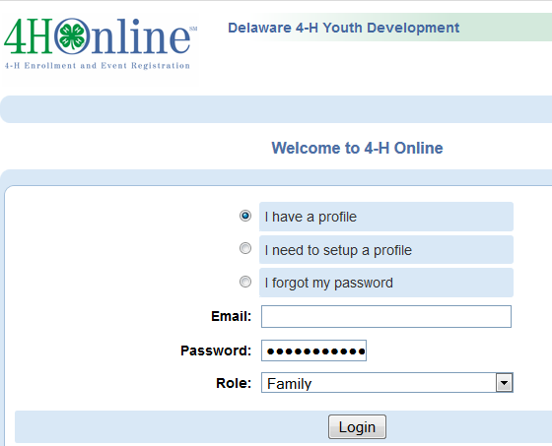
To enroll in Delaware 4-H online, you need a computer, internet access, a valid e-mail address and a web browser (Mozilla or Chrome--not Internet Explorer).

- Go to http://Delaware.4honline.com (notice there’s no “www” in that address).
- Click “I need to set up a profile”. A drop down menu will appear. Select the county you want to join, then type in your valid family e-mail address.
*E-mail addresses must be valid in order for you to have access to your enrollment information—it’s your account login as well as how you receive information. *
- Confirm your e-mail address
- Type in your parent/guardian/household’s last name. (This will be the name that appears on mailing labels—“The Johnson Family” for example.)
- Create your password – must include letters and numbers/symbols with a minimum of 8 characters.
- Click on “Create Login”
To move between boxes, you need to use your mouse or the TAB key. Don’t press the ENTER key or click on the BACK ARROW – you will lose any information that you have entered.
- This is the Family Information page. Fill in all your personal information correctly and completely. Make sure that you choose your correspondence preference.
- Do not check the “update member records” box at this time.
- Click on the “Continue” button at the bottom of the page.
- You are now at the “Member List” page. In the drop down box under “Add a New Family Member”, select “youth” and click on “Add Member”.

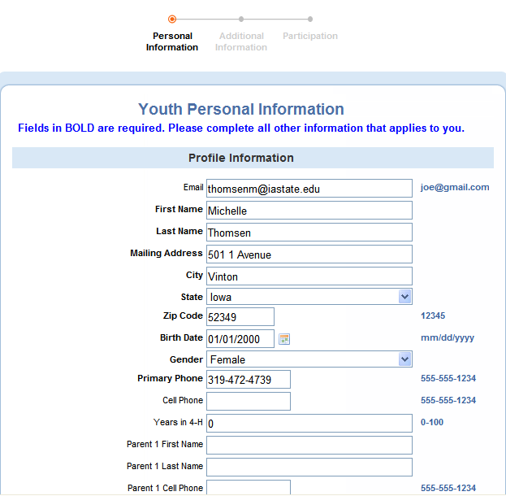
This is the “Youth Personal Information” screen. Fill in all information for this member correctly and completely.

- If he/she has a DIFFERENT e-mail address than the family one entered at login, enter it in the top box.
- If his/her last name is different than the parent/guardian/household name, make that change on this page.
- For the “Years in 4-H”, enter “1” if this is the first year.
- If there are parents/guardians that do not live in the same residence as you, you may enter their mailing information under Secondary Household.
- Are you a volunteer? Mark “no” for youth, “yes” if you’re entering an adult volunteer record.
- Ethnicity – if you consider yourself/child to be a part of the Hispanic culture, mark “yes”.
- You may choose any of the other options listed below or mark “prefer not to state”. The choice is yours.
- Choose your residence.
- Complete the Military Service of Family only if it applies.
- Select your child’s current grade in school.
- Text messaging: This is optional. Enter a cell number, check the box if you are willing to receive text messages via 4-H Online and choose your provider from the list. Texts will be used for last minute meeting notices and other priority information, only from county staff, not auto-generated through the program.
- Be sure to enter an emergency contact name and at least one phone number (required fields). This should be someone OTHER than a parent, if possible. Parents are always contacted first, but who should be called if the parents are not available?
- When you have completed this page, click "Continue." This brings you to the Additional Information Page.

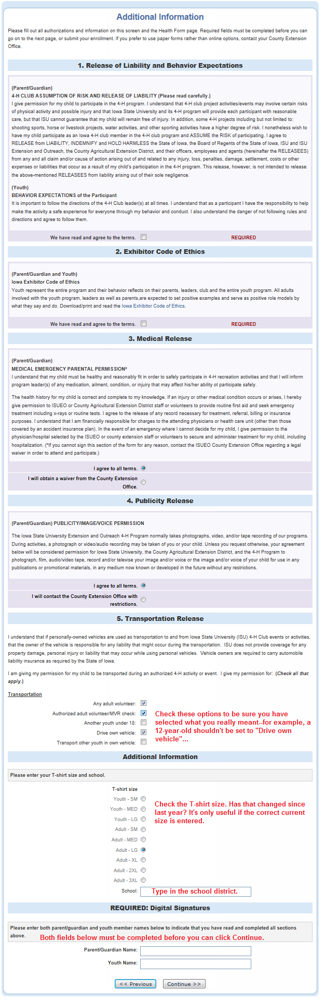
Authorizations and Releases
- All fields are required. Select an option if there is a choice, or check the “I agree…” box.
- Double-check the transportation options that are selected. Are these accurate?
- Additional Information
- Double-check the t-shirt size. Is this still correct, or has that changed since last year?
- Type in the school district name in the box provided.
- Digital Signatures
- Enter both the name of the parent/guardian and the youth. Both fields must be filled in before you can click the Continue button.
- By logging on with your user ID and password, you are indicating that you are the correct person to agree to the terms.
- When you have completed this page, click "Continue." This brings you to the Health Page.

Health Form (below) -
Check all health conditions and allergies that apply. Any health issues not listed need to be entered in the text boxes.
- When you have completed this page, click "Continue."

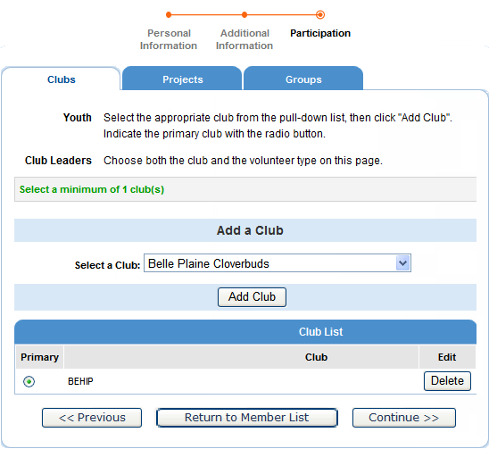
The Clubs/Projects/Groups page is where you will select a 4-H club and projects for the current 4-H year.

- Select the correct club from the drop down menu and click on it.
- Be sure to click “Add Club”.
- If your child is a member of more than one club, add the next one the same way. Make sure that the main club has the blue dot next to it.
- Click the “Continue” button.

The “Projects” tab.
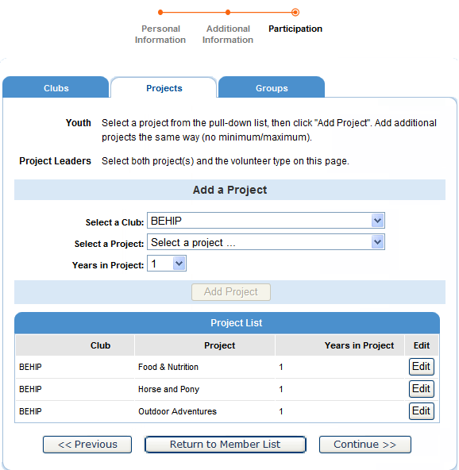
- Under “Select a Project” click on the drop down menu and select the first project for this youth.
- “Years in Project” – must have 1 for 1st year members. For returning members, the years are automatically updated.
- Click on “Add Project”.
- For each additional project that you want to add, repeat the steps above.

Once you have entered all your project(s), you need to click on “Submit Enrollment” and you are done! (DO NOT click “Continue” to go on to the Groups tab)

If there is another youth (or an adult leader) in your family enrolling in 4-H, you will need to repeat this process for them. There is an option for to “copy parent information from another youth record” drop box that will shorten the process some for the second (and beyond) youth.
Once your enrollment has been submitted, it is sent to your County Extension Office to be approved. If there are any problems with your enrollment – incorrect or missing information, etc. – you will get an e-mail with instructions for logging back in (with the same email/password you set up) and correcting those. If there are no problems, you will receive an e-mail stating that you have been accepted and will have access online to your enrollment to make any updates throughout the 4-H year.
Keep your login (family email address) and password handy so that you can log in to the program and update your records whenever you need to.
Next year, when it’s re-enrollment time, you’ll log in to the records you created this year, and simply “reactivate” any members or adult volunteers in your family—the family information only needs to be entered once—when your family begins your 4-H adventure!

FAQ – Frequently asked Questions
Passwords and E-mail Addresses

Q: I forgot my password, how can I get it?
A: On the login page, click on "I forgot my password" and then click "Send My Password"

Q: I forgot the e-mail address that I used, how can I get it?
A: You will need to contact your county Extension office and ask them to look at your profile for the correct e-mail address.

Q: I requested my password to be sent, but it never came, what can I do?
A: Contact your county Extension office and ask for your password to be reset.

Q: If I forgot my e-mail and/or password, can I just set up another profile?
A: NO! If you do that it duplicate the enrollment numbers in the system and creates multiple profiles for families and 4-H members and does not allow you to create a "transcript" of all your 4-H events.

Q: I was given/e-mailed a password but when I typed it in, but it did not work?
A: Because of the sensitivity of the passwords it is recommended that you "cut and paste" the password into the password field. Then once you are logged into the system, you can reset it to something more memorable, as long as it has a minimum of 8 characters & includes letters, plus numbers and/or symbols.

Family and Individual Profile

Q: Now that the new 4-H year has started, do I create a new family profile, or a new member profile?
A: No, to re-enroll all you have to do is access your CURRENT family profile, click on each name of the person re-enrolling (youth and adult) and review the information for correctness. Once complete, make sure you submit your enrollment.

Q: I completed my profile over a week ago and it is still pending, what do I do?
A: Contact your county Extension office and ask them to approve your enrollment, or ask if there are any problems with it.

